Name Bilal Abid Abbasi

Class 1 semester

Pf lab assignment

Iqra University
Islamabad Campus Fall Semester 2026

LAB TASK 9
Course Code: CSC 131 | Course Title: Programming Fundamental
Teacher’s Name: Mr. Ilyas Badshah | Total Marks: 10
Deadline: 10 Jan 2026 | Time: 11 59 pm

Test Exercise
1. Write a program to display the following Patterns.
Sample Output:
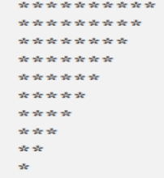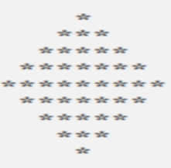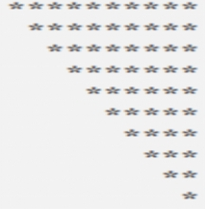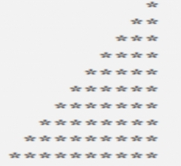

solution
Pattern 1 (Triangle of stars):
*
**
***
****
*****
Pattern 2 (Number Pyramid):
1
12
123
1234
12345
Pattern 3 (Inverted triangle):
*****
****
***
**
*

